REAL TIME INDUSTRIAL PROCESS MONITORING AND CONTROL

ABSTRACT

In spinning mills Petrochemical based cleaning solutions are used for cleaning of raw cotton. This petrochemical liquid is pumped from tank to the process container by using an AC motor. The process container is the capacity of 2000 liters. The motor takes more than one hour to fill the process container. An operator has to pay attention to the container to switch off the motor to avoid overflow of petrochemical. During the process 390C temperature has to be maintained.

If a system is developed for automation of pump for filling the container, no operator is required for supervising the system. Automatic water level controllers are already available in the market. But these controllers are not suitable for this application, as the electrodes are having direct contact with the content. As it is petrochemical based liquid, direct contact with electrodes is not acceptable.

We implemented a unique system for this application by using magnetic sensors. The sensors are placed inside a hollow tube at regular intervals to indicate low, med, high liquid levels. A floating magnet floats on the liquid and triggers the magnetic sensors one-by-one based on the liquid level. Microcontroller monitors the liquid level and the level displayed on LCD. If the maximum level is reached, the microcontroller switches off the motor. If the liquid reaches the lower level, the controller drives the driver circuit and switches on the motor. A precision temperature sensor is used as temperature sensor.

The microcontroller compares the temperature with a ref constant (set by the supervisor) and if the temperature increases beyond 390C, the controller drives the siren circuit to alert the operator.

This project is specially designed for spinning / cotton process Industries. Direct contact of level probes with the content / liquid is completely avoided in this project. Magnetic sensors / Reed switches are used as level sensors. Thermistor is used as temperature sensor. The level of the content and its temperature is monitored by the microcontroller and displayed on LCD.

Relay driver circuit can be activated by sensing “Level Full” and “Low Level” indicators and operates the motor automatically. Siren driver circuit would be activated by thermistor sensor.

As magnetic sensors / reed switches are used, the problem of oxidization of level probes is completely eliminated. This is an advanced, trouble-free, fit and forgets system for industrial applications.

BLOCK DIAGRAM

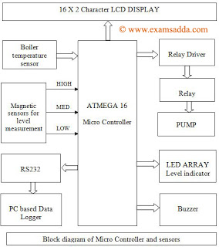

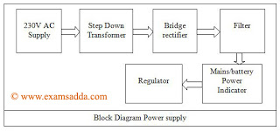

Advantages:

Fit and forget system

Digital Level Display on 16X2 LCD

Temperature Monitoring

Magnetic Sensors

Free from floride and oxidization

§Buzzer indication on abnormal temperature

Scopes for Advancements:

Reliability of liquid level can be increased by increasing number of sensors.

Auto temperature control can be set up in case of abnormal temperature condition

Applications:

Spinning mills

Cotton process industries

Petrochemical industries

Liquid level sensing units